Sri Lanka Institute of Information

Technology



Lab Submission

Lab sheet 07

**IT24102807**

**Jayasinghe T.T.A**

**Probability and Statistics | IT2120**

B.Sc. (Hons) in Information Technology

**Exercise**

Q1.

Q2.



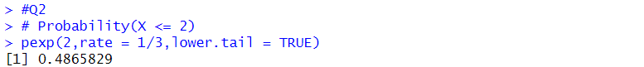

Q3. Part 1

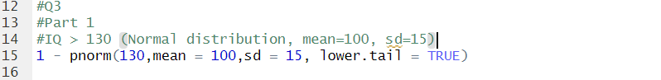

Q3. Part 2

